SUPPLEMENTARY INFORMATION

List of species currently considered part of the Liolaemus elongatus-kriegi complex.

Liolaemus antonietae Troncoso-Palacios, Esquerré, Urra, Diaz, Castro-Pastene & Ruiz 2018
Liolaemus antumalguen Avila, Morando, Perez & Sites 2010
Liolaemus austromendocinus Cei 1974
Liolaemus buergeri Werner 1907
Liolaemus burmeisteri Avila, Perez, Medina, Sites & Morando 2012
Liolaemus capillitas Hulse 1979
Liolaemus carlosgarini Esquerré, Núñez & Scolaro 2013
Liolaemus choique Abdala, Quinteros, Scrocchi & Stazzonelli 2010
Liolaemus crandalli Avila, Medina, Perez, Sites & Morando 2015
Liolaemus curis Núñez & Labra 1985
Liolaemus dicktracyi Espinoza & Lobo 2003
Liolaemus elongatus Koslowsky 1896
Liolaemus flavipiceus Cei & Videla 2003
Liolaemus frassinettii Núñez 2007
Liolaemus gununakuna Avila, Morando, Perez & Sites 2004
Liolaemus heliodermis Espinoza, Lobo & Cruz 2000
Liolaemus janequeoae Troncoso-Palacios, Diaz, Puas, Riveros-Riffo & Elorza 2016
Liolaemus kriegi Müller & Hellmich 1939
Liolaemus leopardinus Müller & Hellmich 1932
Liolaemus lonquimayensis Escobar-Huerta, Santibáñez-Toro & Ortiz, 2015
Liolaemus normae Esquerré, Ramírez-Álvarez, Pavón-Vásquez, Troncoso-Palacios, Garín, Keogh & Leaché, 2019
Liolaemus parvus Quinteros, Abdala, Gomez & Scrocchi 2008
Liolaemus petrophilus Donoso-Barros & Cei 1971
Liolaemus punmahuida Avila, Perez & Morando 2003
Liolaemus ramonensis Müller & Hellmich 1932
Liolaemus scorialis Troncoso-Palacios, Esquerré, Diaz & Urra 2015
Liolaemus shitan Abdala, Quinteros, Scrocchi & Stazzonelli 2010
Liolaemus smaug Abdala, Quinteros, Scrocchi & Stazzonelli 2010
Liolaemus talampaya Avila, Morando, Perez & Sites 2004
Liolaemus tregenzai Pincheira-Donoso & Scolaro 2007
Liolaemus tulkas Quinteros, Abdala, Gomez & Scrocchi 2008
Liolaemus ubaghsi Esquerré, Troncoso-Palacios, Garin & Núñez 2014
Liolaemus umbrifer Espinoza & Lobo 2003
Liolaemus valdesianus Hellmich 1950
Liolaemus zabalai Troncoso-Palacios, Esquerré, Diaz & Urra 2015

Figure S1. Dorsal and ventral views of the holotype of L. normae sp. nov (SSUC-RE 738). Photo by DE.

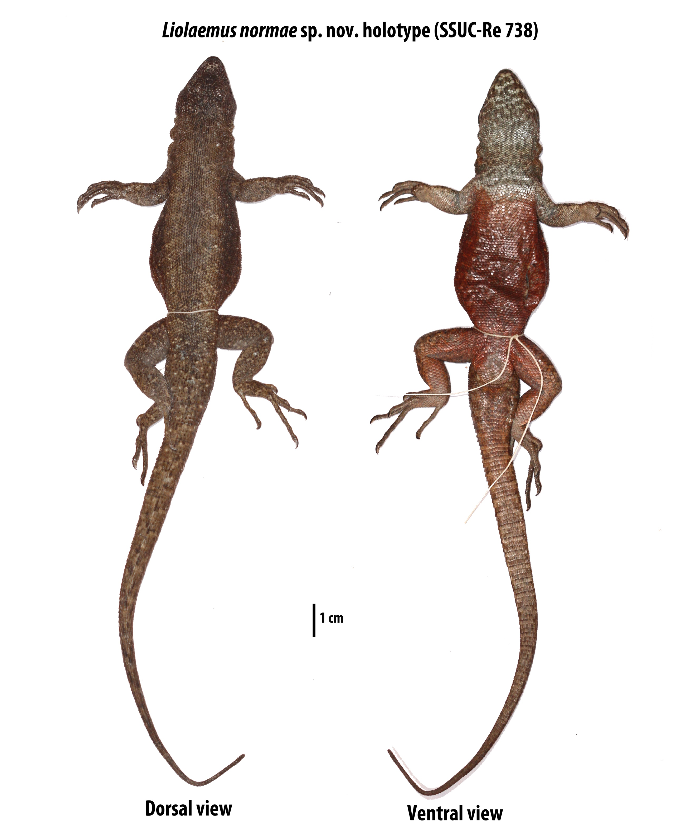

Figure S2. Holotype and paratypes of L. normae sp. nov. Above, dorsal view; below, ventral view. Photo by DE.
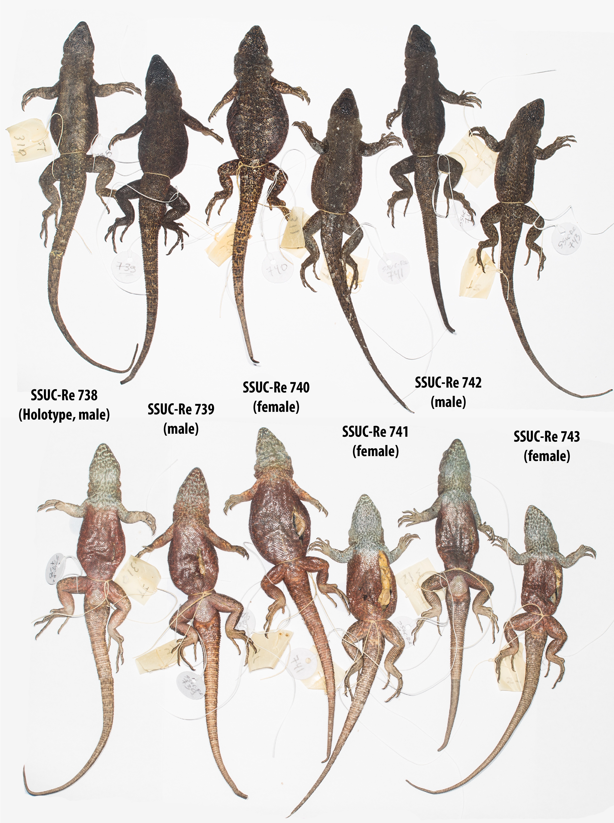

Figure S3. Comparison of live individuals of L. normae sp. nov. and L. ubaghsi. Photos by JTP.

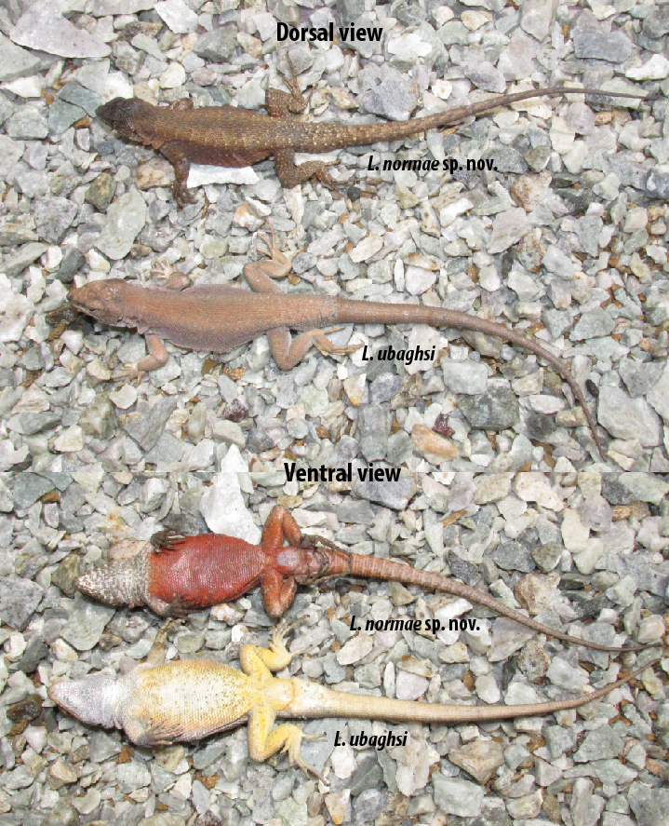

Figure S4. Live individuals of L. normae sp. nov. in its habitat. Photos by DRA.

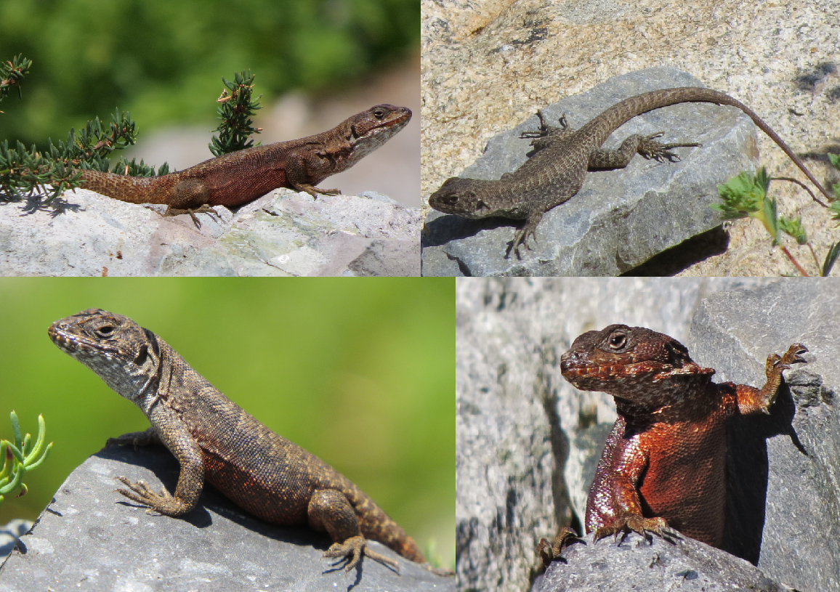

Figure S5. Los Cristales Lagoon, type locality and habitat of L. normae sp. nov. Photo by DRA.
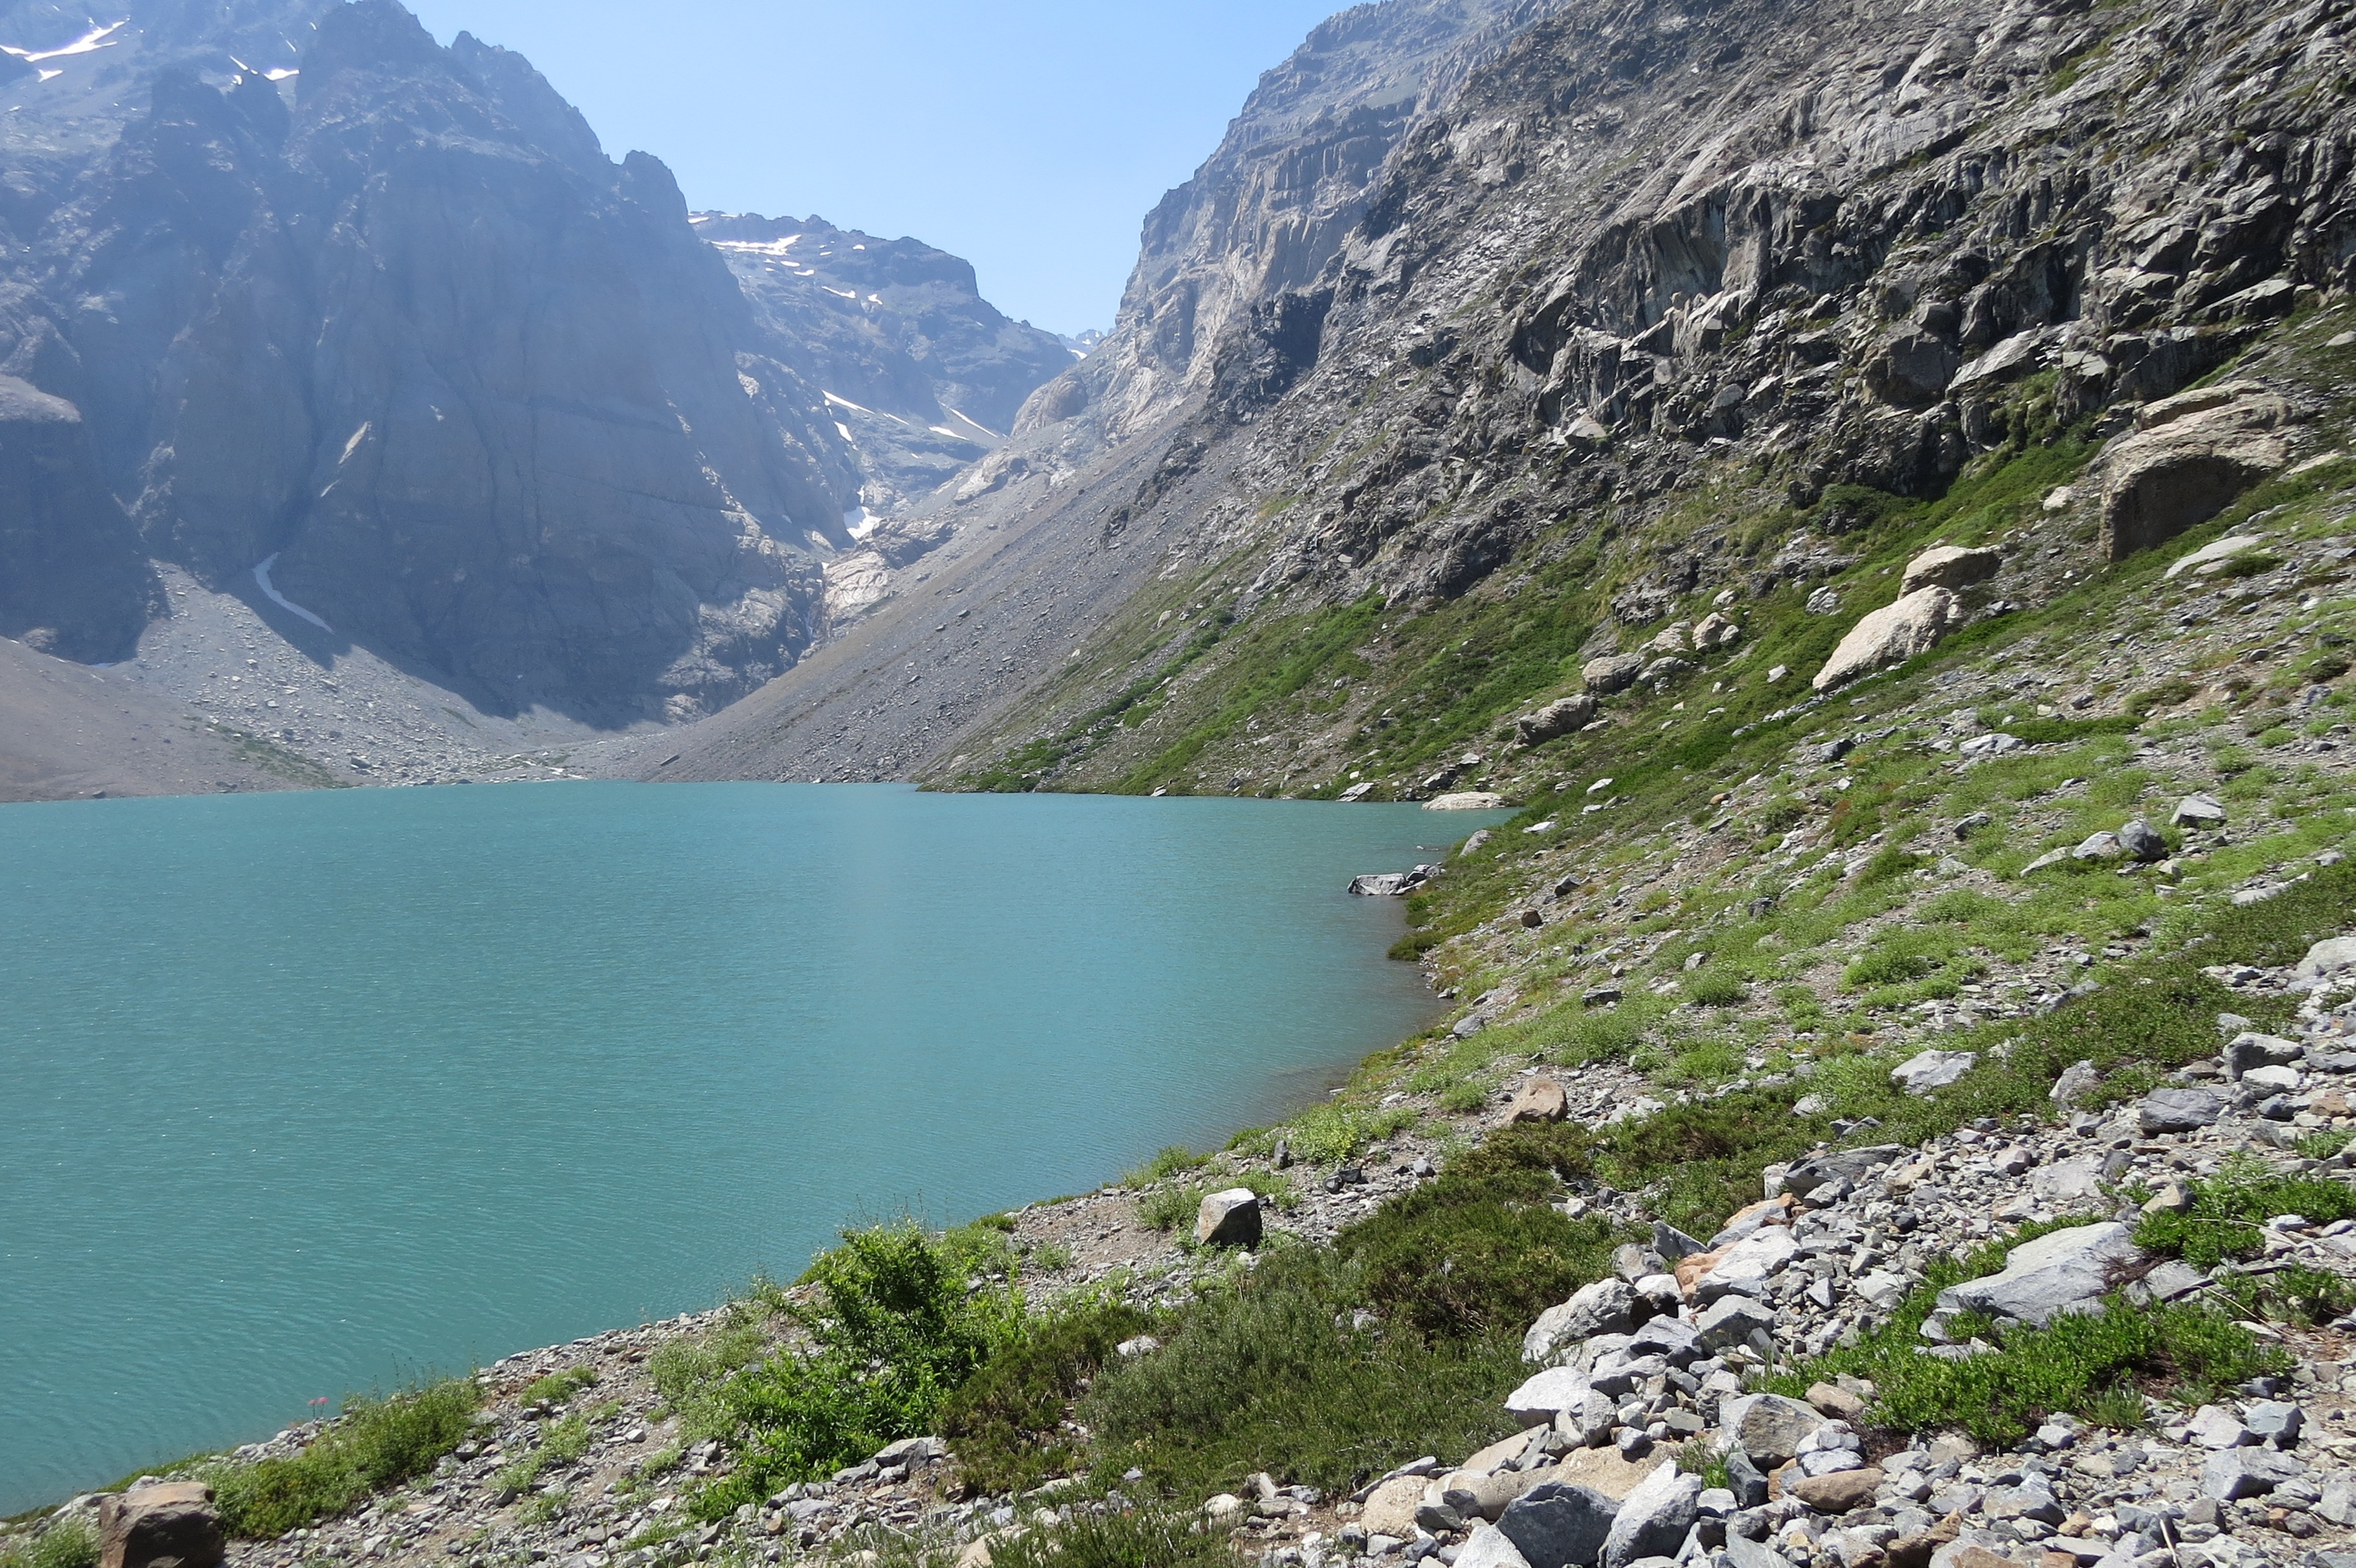

Table S1. Specimens used in this study, separated by taxon and locality. No symbol: morphology only. ¹: mtDNA only. ²: morphology plus mtDNA. ³: mtDNA and nDNA, ⁴: morphology, mtDNA and nDNA

Species | Locality | Samples
L. leopardinus | El Colorado (33°19'60"S - 70°16'60"W) | MNHN 3437, MNHN 3438, MNHN 3439, MNHN 4890², MNHN 4891 ⁴
 | Farellones (33°20'31"S - 70°17'32"W) | MNHN 4025, MNHN 4027, MNHN 4028, SSUC-Re 364, SSUC-Re 366 ², SSUC-Re 367 ², SSUC-Re 719, SSUC-Re 3720, SSUC-Re 721
 | Casa Piedra (33°21'00"S - 70°17'00"W) | DD 065 ³, DD 071 ³
 | Yerba Loca (33°15'00"S - 70°17'00"W) | JTP 333 ², JTP 336
 | Conchalí Mountain (33°16'00"S - 70°28'00"W) | SSUC-Re 747 ⁴, SSUC-Re 748 ¹, SSUC-Re 749
L. ramonensis  (= L. leopardinus) | Quebrada de Macul (33°29'26"S - 70°26'31"W) | MNHN 4005, MNHN 4006, MNHN 4007, MNHN 4008, MNHN 4009, MNHN 4010, MNHN 4011, MNHN 4012, MNHN 4013, MNHN 4014, MNHN 4015, MNHN 4016, MNHN 4017
 | Lagunillas (33°36'00"S - 70°16'60"W) | SSUC-Re 653 ⁴, SSUC-Re 655 ⁴, SSUC-Re 722, SSUC-Re 723, SSUC-Re 724, DE 05 ¹
 | San Ramon Mountain (33°29'05"S - 70°26'34"W) | MNHN 4013, CN 217, CN 204, CN 4006, SSUC-Re 490 ³
 | Provincia Mountain (33°25'33"S - 70°26'22"W) | SSUC-Re 726, DD 034 ³
L. valdesianus | Morado Mountain (33°47'00"S - 70°02'00"W) | MNHN 0002, MNHN 0004, MNHN 0005, MNHN 0006, CN 0003, CN 0007, CN 0008, CN 0009, CN 0010, CN 0012
 | Lo Valdés (33°51'00"S - 70°03'00"W) | SSUC-Re 129, SSUC-Re 363 ², JTP 101 ³
 | El Yeso (33°38'18"S - 70°01'46.78"W) | SSUC-Re 559, CN 403, SSUC-Re 744 ⁴, SSUC-Re 745 ², SSUC-Re 746
 | Baños Colina (33°51'12"S - 69°58'52"W) | MNHN 2797
 | Valle La Engorda (33°47'00"S - 69°59'00"W) | CG 004 ³
L. frassinettii | Altos de Cantillana (33°53'00"S - 70°57'00"W) | MNHN 524, MNHN 1035, MNHN 4140², MNHN 4141², MNHN 4142, SSUC-Re 0080 ², DD 069 ³
L. ubaghsi | Chapa Verde (34°03'2"S - 70°26'28"W) | MNHN 3808, MNHN 3809, MNHN 3810, MNHN 3811, MNHN 3812, MNHN 3813, MNHN 3814, MNHN 3815, JTP 313, DD 045 ³
 | Tranque Barahona (34°04'25"S - 70°30'33"W) | SSUC-Re 491 ⁴, SSUC-Re 492 ²
 | Colón (34°05'11"S - 70°27'08"W) | CN 605, CN 608, CN 609, CN 611, CN 612
 | Tinto River (33°58'00"S - 70°25'00"W) | SSUC-Re 735 ⁴
L. normae sp. nov. | Los Cristales Lagoon (34°34'00"S - 70°31'00"W) | SSUC-Re 738, SSUC-Re 739, SSUC-Re 740, SSUC-Re 741², SSUC-Re 742⁴, SSUC-Re 743

Table S2. Pairwise comparisons between species least squares means of phenotypic distances. Upper triangles display the distances and the lower triangles the P values of the comparisons (significant ones are in bold).

 | L. frassinettii | L. leopardinus | L. normae | L. ubaghsi | L. valdesianus
Body shape
L. frassinettii | - | 13.012 | 10.771 | 15.334 | 22.040
L. leopardinus | 0.0041 | - | 6.40 | 6.18 | 9.24
L. normae | 0.078 | 0.190 | - | 8.361 | 14.080
L. ubaghsi | 0.001 | 0.031 | 0.089 | - | 11.045
L. valdesianus | 0.0001 | 0.0005 | 0.001 | 0.001 | -
Dorsal view of head shape
L. frassinettii | - | 0.026 | 0.036 | 0.015 | 0.022
L. leopardinus | 0.105 | - | 0.033 | 0.027 | 0.023
L. normae | 0.075 | 0.015 | - | 0.038 | 0.044
L. ubaghsi | 0.717 | 0.001 | 0.006 | - | 0.023
L. valdesianus | 0.310 | 0.009 | 0.001 | 0.036 | -
Lateral view of head shape
L. frassinettii | - | 0.021 | 0.036 | 0.017 | 0.019
L. leopardinus | 0.282 | - | 0.027 | 0.023 | 0.021
L. normae | 0.048 | 0.050 | - | 0.030 | 0.035
L. ubaghsi | 0.711 | 0.003 | 0.035 | - | 0.024
L. valdesianus | 0.509 | 0.007 | 0.007 | 0.014 | -

Table S3. Eigenvalues, percentage of variance explained, cumulative percentage of variance explained and eigenvectors (loadings) of each trait for each of the principal components on body shape. Traits with the heaviest loadings are in bold.

Eigenvalues | PC1 | PC2 | PC3 | PC4 | PC5
Eigenvalue per Comp. | 3.44 | 2.99 | 2.28 | 2.06 | 1.73
% of var. | 12.3 | 10.7 | 8.15 | 7.37 | 6.17
Cum. % of var. | 12.3 | 22.99 | 31.15 | 38.52 | 44.69
Eigenvectors | PC1 | PC2 | PC3 | PC4 | PC5
SVL | 0.401 | 0.554 | 0.014 | -0.302 | 0.381
AGD | 0.258 | 0.574 | -0.393 | -0.420 | 0.025
TL | 0.618 | -0.016 | -0.012 | 0.256 | -0.115
Foot length | 0.178 | -0.262 | -0.369 | 0.470 | 0.311
Tibial length | 0.183 | 0.060 | -0.501 | 0.146 | 0.307
Femoral length | -0.143 | -0.189 | 0.028 | 0.289 | 0.199
Humeral length | -0.082 | 0.252 | -0.220 | -0.253 | 0.330
Radial length | 0.004 | 0.006 | -0.083 | 0.552 | 0.340
Hand length | 0.450 | -0.072 | 0.018 | 0.171 | -0.029
Head length | -0.054 | 0.313 | 0.364 | -0.052 | 0.569
Head didth | 0.218 | -0.171 | 0.481 | -0.060 | 0.558
Head depth | 0.321 | 0.097 | 0.262 | -0.217 | -0.187
Rostral width | -0.307 | 0.043 | 0.043 | -0.157 | 0.149
Rostral height | -0.396 | -0.054 | 0.207 | 0.090 | -0.130
Internarial distance | -0.382 | 0.068 | 0.191 | 0.171 | -0.252
Inter eye distance | 0.250 | -0.114 | 0.520 | 0.118 | 0.045
Eye ear distance | -0.384 | -0.190 | 0.513 | -0.302 | 0.072
Loreal length | -0.043 | 0.098 | 0.423 | -0.319 | -0.093
Eye length | -0.711 | 0.285 | -0.122 | 0.237 | 0.154
Neck width | 0.787 | -0.431 | -0.016 | -0.056 | -0.181
Ear oppening height | -0.166 | -0.071 | -0.371 | -0.062 | -0.264
Ear oppening width | -0.553 | 0.113 | -0.221 | -0.004 | -0.195
Scales around midbody | 0.351 | 0.372 | 0.361 | 0.343 | -0.282
Dorsal scales | 0.381 | 0.657 | -0.143 | -0.065 | -0.087
Ventral scales | 0.084 | 0.742 | 0.154 | 0.256 | -0.259
Third finder lamellae | -0.186 | 0.631 | 0.061 | 0.085 | -0.026
Third toe lamellae | 0.037 | 0.145 | 0.213 | 0.472 | -0.054
Fourth toe lamellae | -0.093 | 0.388 | 0.181 | 0.454 | 0.036

Table S4. Summary of selected morphological measurements of the populations in the L. leopardinus clade. Abbreviations are as follows: n, sample size; SVL, Snout-vent length; SAMB, Scales around mid-body; DS, Dorsal scales; VS, Ventral scales. San Ramon includes Pronvincia Mountain and Quebrada de Macul, and Farellones includes Colorado, Cajon del Maipo includes Morado Mountain, Lo Valdes and Baños Colina; Sewell includes Chapa Verde, Tranque Barahona and Colón.

Species | L. ubaghsi |  | L. valdesianus |  | L. frassinettii | L. leopardinus |  |  |  |  | L. normae sp. nov.
n | Total (n=17) |  | Total (n=18) |  | Total (n=6) | Total (n=41) |  |  |  |  | Total (n=6)
 | Sewell (n=16) | Tinto River (n=1) | Cajon del Maipo (13) | El Yeso (n=5) | Cantillana (n=6) | San Ramon (n=18) | Lagunillas (n=5) | Farellones  (n=14) | Yerba Loca (n=2) | Conchalí (n=2) | Cristales Lagoon (n=6)
Mean SVL | 84.5 |  | 84.4 |  |  | 87.23
 | 84 | 94.27 | 83.43 | 87.85 | 76.4 | 88 | 80.7 | 87.9 | 96.2 | 83.97 | 83.2
Max SVL | 94.3 |  | 95 |  |  |  |  | 99.13
 | 94.3 | 94.27 | 95 | 92.5 | 85.6 | 94.9 | 91.54 | 99.13 | 97.03 | 84.75 | 88.76
SAMB | 78.7 (71-87) |  | 76 (69-89) |  |  |  |  | 80.5 (75-89)
 | 78.6 (71-87) | 81 | 75.9 (69-89) | 76.5 (72-82) | 86.8 (80-93) | 79.6 (75-85) | 79.4 (75-84) | 81.3 (76-89) | 83.5 (81-86) | 82.3 (79-84) | 86 (80-93)
DS | 70 (62-83) |  | 70.5 (66-78) |  |  |  |  | 74.5 (63-84)
 | 70.5 (64-83) | 62 | 71.21 (68-78) | 68 (66-71) | 82 (72-89) | 74.2 (63-84) | 76.6 (72-83) | 75 (66-84) | 69 (66-72) | 74.7 (73-77) | 73.2 (67-81)
VS | 119 (110-137) |  | 109.4 (100-123) |  |  |  |  | 116.1 (105-136)
 | 119.6 (111-137) | 110 | 108.24 (100-123) | 112.3 (103-121) | 125.3 (111-140) | 115.5 (105-136) | 120.2 (112-130) | 116.14 (106-129) | 115 (114-116) | 112.7 (111-114) | 118.5 (108-128)
Precloacal pores | 4-5 |  | 3-4 |  |  |  |  | 0-5
 | 4 | 5 | 3-4 | 3-4 | 3 | 3-5 | No males | 0-4 | 4 | 3-5 | 0-3
3rd finger lamellae | 22.3 (20-27) |  | 20.3 (18-23) |  |  |  |  | 21.35 (18-25)
 | 22.4 (20-27) | 22 | 20.4 (18-23) | 20.3 (19-22) | 22.3 (21-24) | 21.3 (18-25) | 21.6 (20-24) | 21.7 (20-24) | 20.5 (20-21) | 19.3 (19-20) | 20.3 (19-22)
3rd toe lamellae | 23.8 (22-27) |  | 22.5 (19-25) |  |  |  |  | 23.1 (20-26)
 | 23.8 (22-27) | 25 | 22.4 (19-25) | 23 (19-25) | 23 (20-25) | 23.3 (20-26) | 22.8 (22-25) | 22.7 (21-25) | 23 (22-24) | 24.7 (23-26) | 24.2 (23-26)
4th toe lamellae | 31.3 (28-35) |  | 27.3 (25-31) |  |  |  |  | 29.2 (25-32)
 | 31.4 (28-35) | 31 | 27.4 (25-30) | 27 (25-31) | 28.5 (26-32) | 29.5 (25-32) | 28.6 (27-31) | 28.9 (25-31) | 29 | 29 (27-31) | 29.8 (29-31)

Table S5. Measurements and scale counts of the type series of L. normae sp. nov. Abbreviations correspond to reg, regenerated; squa., squashed.

Specimen | SSUC-Re 738 | SSUC-Re 739 | SSUC-Re 740 | SSUC-Re 741 | SSUC-Re 742 | SSUC-Re 743 | Mean
Sex | Male | Male | Female | Female | Male | Female
SVL (Snout-vent length) | 88.76 | 85.71 | 85.89 | 79.7 | 87.45 | 71.71 | 83.20
AGD (Axilla-groin distance) | 37.48 | 34.02 | 38.79 | 35.67 | 34.64 | 28.28 | 34.81
TL (Tail length) | 140.82 | tip missing | Reg. | Reg. | Reg. | 127.33 | 134.08
LFLL (Left front limb length) | 30.29 | 31.09 | 27.68 | 30.24 | 27 | 25.96 | 28.71
LHLL (Left hind-limb length) | 55.12 | 52.18 | 45.03 | 48.79 | 50.4 | 47.41 | 49.82
Foot length | 26.23 | 25.85 | 25.08 | 25.19 | 25.57 | 24.02 | 25.32
Tibial length | 17.68 | 16.29 | 16.31 | 19.37 | 16.63 | 16.63 | 17.15
Femoral length | 17.7 | 18.93 | 15.15 | 16.88 | 17.06 | 15.75 | 16.91
Humeral length | 10.15 | 12.06 | 11.1 | 13.2 | 10.18 | 8.26 | 10.83
Radial length | 11.55 | 11.14 | 9.96 | 10.49 | 12.1 | 10.39 | 10.94
Hand length | 15.45 | 12.91 | 13.22 | 14.41 | 15.1 | 13.78 | 14.15
Head length | 18.94 | 18.51 | 17.7 | 17.54 | 18.98 | 17.13 | 18.13
Head width | 15.85 | 13.74 | 15.59 | 15.63 | 16.22 | 14.77 | 15.30
Head depth | 11.34 | 10.13 | 9.79 | 8.5 | 11.03 | 6.56 (head squa.) | 10.16
Scales around mid-body | 89 | 93 | 86 | 80 | 87 | 81 | 86.00
Dorsal scales | 76 | 71 | 81 | 67 | 74 | 70 | 73.17
Ventral scales | 123 | 128 | 122 | 108 | 120 | 110 | 118.50
Precloacal pores | 3 | 3 | 0 | 0 | 3 | 0 | 1.50
Rostral width | 4.75 | 3.85 | 3.71 | 3.54 | 3.5 | 3.65 | 3.83
Rostral height | 1.98 | 1.83 | 1.2 | 1.24 | 1.48 | 1.77 | 1.58
Internarial distance | 4.1 | 4.54 | 3.25 | 4.61 | 4.75 | 3.9 | 4.19
Inter-eye distance | 10.51 | 10.24 | 10.13 | 8.97 | 10.65 | 9.78 | 10.05
Ear-eye distance | 7.17 | 7.34 | 5.12 | 6.24 | 6.58 | 6.58 | 6.51
Loreal length | 5.59 | 6.06 | 3.34 | 4.48 | 3.96 | 5.31 | 4.79
Eye length | 3.85 | 4.4 | 3.97 | 5.91 | 5.98 | 4.13 | 4.71
Neck width | 16.84 | 18.92 | 17.72 | 17.54 | 17.63 | 16.84 | 17.58
Ear oppening height | 3.71 | 3.93 | 3.79 | 4.38 | 4.26 | 3.52 | 3.93
Ear oppening width | 1.83 | 1.92 | 1.46 | 1.59 | 2.23 | 1.93 | 1.83
Third finger lamellae | 19 | 20 | 19 | 22 | 21 | 21 | 20.33
Third toe lamellae | 23 | 24 | 23 | 26 | 25 | 24 | 24.17
Fourth toe lamellae | 30 | 31 | 28 | 29 | 31 | 30 | 29.83

